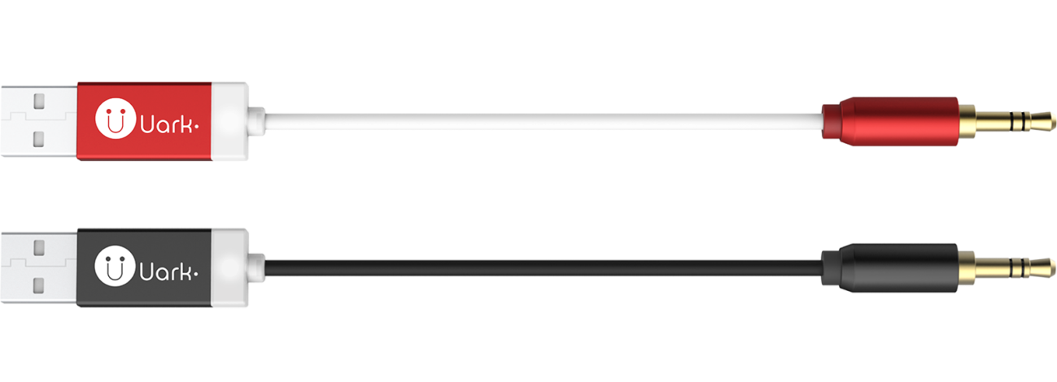

Uark 7 Bluetooth to AUX Music Receiver
Specifications

Physical Characteristics
Dimensions (L x W x H) | 168 x 5.5 x 13 mm
Weight | 10 gram
Case | Anodized aluminum
Colour Options | Metallic red, ebony black
Cable | Copper conductor, black or white jacket
Interface
Power Input | USB
Output | 3.5 mm gold-plated audio plug
Environmental Characteristics
Storage Temperature | -20 °C to +80 C°
Operating Temperature | 0 °C to +70 C°
Power Consumption
Stand-by | 20 mA
Connection | 30 mA
Operation | 50 mA
Bluetooth
System | Version 4.0
Communication Range | 10 meters (open space, with no interference)
Supported Profiles | A2DP V1.2 (connection of 2 A2DP sources at the same time)
Supported Codecs | SBC (Sub-band Coding), AAC (Advanced Audio Coding) and MP3
Digital-to-Analog Converter | SNR 95dB @ 1kHZ, A-Weighted, THD+N < 0.1A
Audio Output Power
Output Level | 1.188 Vrms
Package Content
Uark 7 | Bluetooth to AUX music receiver
Extension Cable | 3.5 mm audio jack to plug, 50 cm long
Documentation | Quick start guide

Uark is a brand created by ARKNAV International Inc.

Contact Uark:
12F.,No.81,Zhongcheng Rd.,
Tucheng Dist., New Taipei City 23674,
Taiwan, R.O.C.
Telephone: +886-2-2267-3723
Fax : +886-2-2267-7300
E-Mail: support@uark.com.tw

